|  |  |
| --- | --- |
| **Vertical full colour positive** | **Year 11 General Biology**  **Task 8 – Adaptations Test** |

|  |  |  |  |
| --- | --- | --- | --- |
| **Name:** | **Teacher:** | **Date:** | **Score: /48** |

**Assessment type:** Test

**Conditions**

Time for the task: 55 minutes

**Task weighting** – 10%

Total 46 marks

**Structure of this paper**

|  |  |  |  |  |
| --- | --- | --- | --- | --- |
|  |  | Suggested working time (minutes) | Marks available | Mark achieved |
| Section 1 | Multiple choice | 15 minutes | **11** |  |
| Section 2 | Short answer | 20 minutes | **27** |  |
| Section 3 | Extended answer | 25 minutes | **10** |  |
|  |  | **Total** | **48** |  |

**Section 1: Multiple-choice (11 marks)**

This section has 15 questions. Answer all questions by circling the letter corresponding to the correct answer.

___________________________________________________________________

1. The body temperature of two different mammals was recorded over 24hours. The average daytime temperature was 40˚C and average night-time temperature was 20˚C. The temperatures of the mammals over the 24 hours are shown in the graph below.

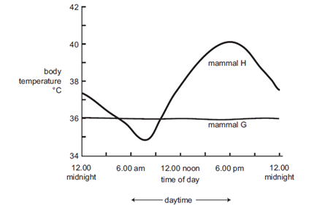

From the information given it would be reasonable to conclude that

1. Between midnight and 6.00am, mammal H would be gaining heat by conduction.
2. At 12.00 noon, mammal H would be gaining heat by radiation.
3. At 12.00 noon, mammal G is losing heat by radiation.
4. Between midnight and 6.00am, mammal G would be losing heat through evaporation
5. Mammals that live in very cold environments have behavioural adaptations that help reduce the rate at which they lose heat. One behavioural adaptation could be
6. Decreasing food intake
7. Having a thick fur coat
8. Curling up into the shape of a ball
9. Isolating themselves from other individuals
10. The desert hopping mouse, *Notomys alexis*, has a physiological adaptation where they can survive indefinitely by eating a diet of dry seeds and without drinking any water. Which of the following statements would **NOT** help to explain this remarkable ability?
11. Seeds are rich in carbohydrates, which produce water when metabolised aerobically.
12. *Notomys* have kidneys which are capable of producing a highly concentrated urine.
13. Small body size helps to reduce evaporation rates at the surface of the animal.
14. These animals spend much of their time in cool, humid, underground burrows.
15. Which of the following statements is true of an endothermic animal?
16. Body temperature remains constant because heat gained from the environment is balanced by heat lost to the environment.
17. Changes in body temperature follow changes in the temperature of the environment.
18. There is no change in metabolic rate as the temperature of the environment changes
19. Heat lost to the environment is replaced by heat generated from metabolic activity.
20. The trout is a fish that spends part of its life in the ocean and part of its life in freshwater. Which of the following statements correctly describes the water and salt balance of a trout in a **freshwater** environment?
21. Water and salts are lost by diffusion. These are balanced by drinking large quantities of water and by active uptake of salts across the gills.
22. Water is gained and salts are lost by diffusion. These are balanced by constant drinking and by active excretion of water across the gills.
23. Water is lost and salts are gained by diffusion. These are balanced by constant drinking and by active excretion of salts across the gills.
24. Water is gained and salts are lost by diffusion. These are balanced by the excretion of dilute urine and by active uptake of salts across the gills.
25. The nitrogen present in proteins can be eliminated in the form of ammonia, which is highly toxic and must be removed from the body rapidly. In which of the following habitats would you be most likely to encounter organisms using ammonia as their nitrogenous waste?
26. in deserts
27. in the air
28. in water
29. in rainforests
30. During spring in southern Australia reptiles such as lizards and snakes become active after a period of dormancy. Initially, they are most active during the daytime. By mid-summer they are most active at night. Which of the following is the best explanation of this?
31. They are hungry in spring after being dormant for so long.
32. They mate in spring and lay eggs in summer.
33. The day temperature determines their active period
34. In the summer they are conserving energy for the cold winter.
35. Which of the following would be a physiological adaptation by an endotherm in a cold environment?
36. vasodilation of skin arterioles to decrease heat loss by radiation.
37. counter-current heat exchange to reduce heat loss from extremities.
38. large amounts of fat under the skin to insulate from heat loss.
39. huddling to reduce the amount of surface area exposed to the environment.
40. Which of the following comparisons concerning freshwater and marine fish is correct?

|  |  |  |
| --- | --- | --- |
|  | Freshwater Fish | Marine Fish |
| a | Large quantities of urine | Small quantities of urine |
| b | Concentrated urine | Dilute urine |
| c | Gain water through gills | Gain ions through gills |
| d | Actively drink water | Don’t drink water |

1. Reptiles can survive without food for much longer periods of time than mammals. The main reason for this is that
2. reptiles produce uric acid as an excretory product.
3. mammals are endothermic and reptiles are ectothermic.
4. reptiles are able to eat more food at any one time than mammals.
5. mammals generally have a larger body size than reptiles.
6. Which of the following is true of a negative feedback homeostatic mechanism?  
   The response…
7. alters the original stimulus.
8. only occurs when there is a strong stimulus.
9. is carried out by receptors.
10. is always of the same intensity.

**Section 2: Short answer (27 marks)**

*Write the answers for each question in the space provided.*

1. The diagram below illustrates the mechanisms involved in the maintenance of a constant body temperature in a terrestrial animal.

hypothalamus

Body Temperature Medulla activity

Shivering panting

Muscle temperature Respiratory tract

temperature

1. This is an example of a stimulus-response negative feedback model of temperature regulation in an endotherm.
2. Define the term “endotherm” (1 mark)

______________________________________________________________________________________________________________________

1. Explain why the animal above must be an endotherm. (1 mark)

_____________________________________________________________________________________________________________________

iii. In the pathway shown above, name the (2 marks)

stimulus: ___________________________________________________

response: ___________________________________________________

1. Name four adaptations not included in the diagram above at the start of the question which might be employed by this animal to keep warm in a cold environment. (4 marks)

_______________________________________________________________________________________________________________________________________________________________________________________________________________________________________________________________________________________________________________________________________________________________________________________

1. Using the diagram below explain how these structures came to be so similar.

(2 marks)

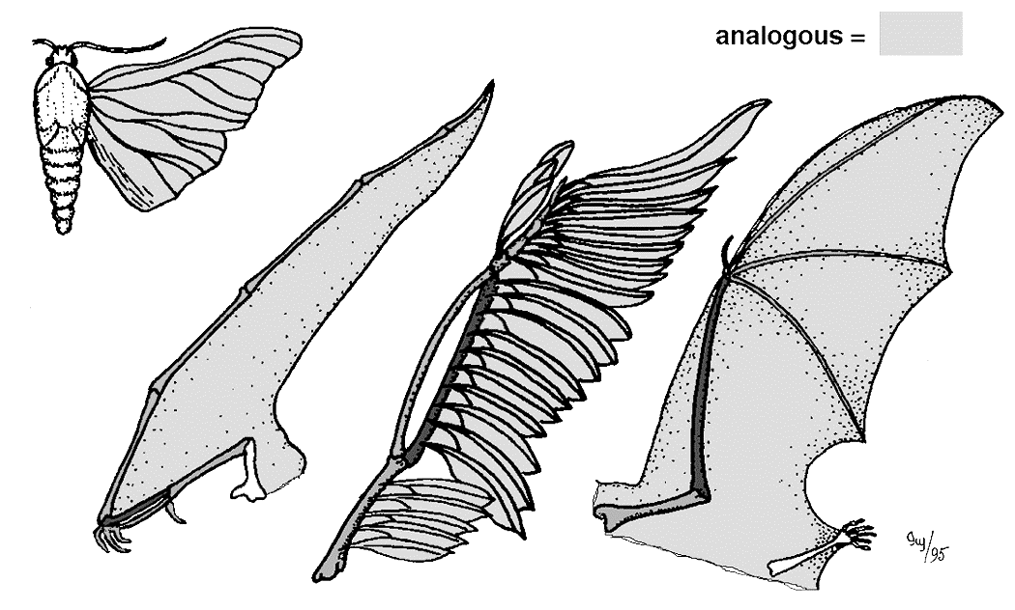

1. Using the diagram below explain how these structures came to be so similar. (2 marks)

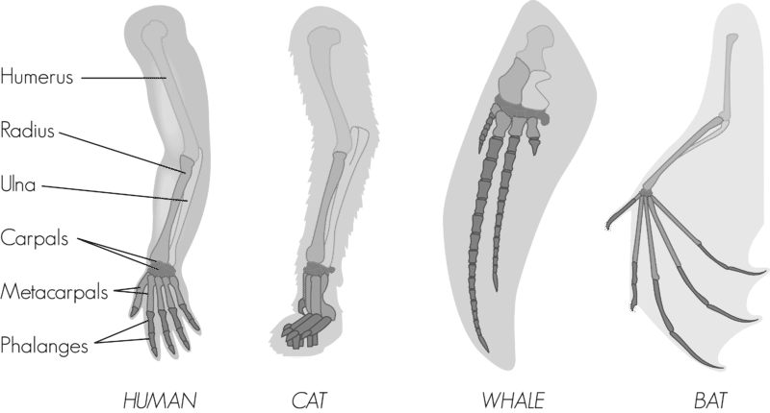

1. What is the difference between a xerophyte and hydrophyte plant? (1 mark)

________________________________________________________________

________________________________________________________________

1. List and describe three adaptations of Australian desert plants that enable them to survive in dry, hot climates. (3 marks)

________________________________________________________________________

________________________________________________________________________

________________________________________________________________________

1. Explain two substances used for the purposes of homeostasis and how these substances are regulated. (4 marks)

________________________________________________________________________________________________________________________________________________________________________________________________________________________

________________________________________________________________________

________________________________________________________________________

1. Label the diagram of the mammalian excretory system below (4 marks)

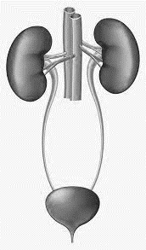

The following picture is of the North Tropical Queensland Rainforest.

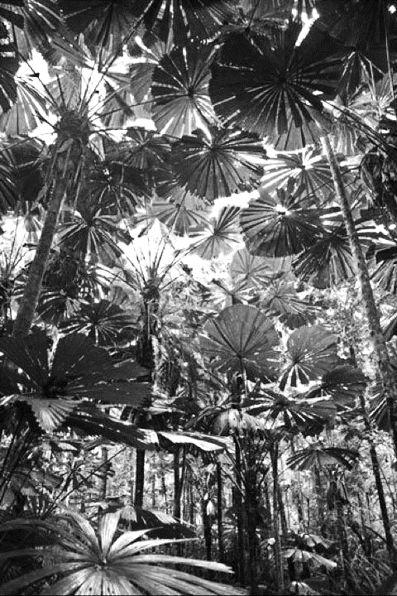

1. List and explain each type of adaptation you would expect to see from the flora and fauna habituating in the North Tropical Queensland rainforest. (3 marks)

|  |  |  |
| --- | --- | --- |
| **Adaptation Type** | **Plant** | **Animal** |
| Structural |  |  |
| Behavioral |  |  |
| Physiological |  |  |

**End of Section 2**

**Section 3: Extended answer (10 marks)**

*Write the answers for this question on the* ***lined paper*** *provided. Make sure you clearly number your answers.*

*In this section, answers may be presented in different ways provided that they communicate your ideas effectively.*

*You may choose to:*

* *present clearly labelled diagrams*
* *write notes beside clear diagrams*
* *write lists of points, with sentences which link them*
* *present information in tables*
* *write concisely worded sentences*
* *use other appropriate ways to present ideas*

Name the type of waste produced by a freshwater fish, a dog and a desert lizard. Explain how these relate to the availability of water in each animal’s environment and the benefits and costs of each type of waste to each animal.

**__________________________________________________________________________________________________________________________________________________________________________________________________________________________________________________________________________________________________________________________________________________________________________________________________________________**

**_______________________________________________________________________________________________________________________________________________________________________________________________________________________________________________________________________________________________________________________________________________________________________________________________________________________________________________________________________________________________________________________________________________________________________________________________________________________________________________________________________________________________________________________________________________________________________________________________________________________________________________________________________________________________________________________________________________________________________________________________________________________________________________________________________________________________________________________________________________________________________________________________________________________________________________________________________________________________________________________________________________________________________________________________________________________________________________________________**

**End of Test**